Practical 7

Part A:
Aim:
1. Form validator: define @NotBlank and @MaxLength(int) for fields and annotate a SignupForm. Write a checker that uses reflection to read each field’s annotations and returns the list of validation errors for a given object.

Code:
NoteBlank.java
import java.lang.annotation.Retention;
import java.lang.annotation.RetentionPolicy;
import java.lang.annotation.Target;
import java.lang.annotation.ElementType;

@Retention(RetentionPolicy.RUNTIME)
@Target(ElementType.FIELD)
public @interface NotBlank {
}

Validator.java
import java.lang.reflect.Field;
import java.util.ArrayList;
import java.util.List;

public class Validator {

public static List<String> validate(Object object) {

List<String> errors = new ArrayList<>();

Class<?> clazz = object.getClass();

for (Field field : clazz.getDeclaredFields()) {

field.setAccessible(true);

try {
Object value = field.get(object);

// Check @NotBlank
if (field.isAnnotationPresent(NotBlank.class)) {

if (value == null ||
value.toString().trim().isEmpty()) {

errors.add(field.getName() + " must not be blank.");
}
}

// Check @MaxLength
if (field.isAnnotationPresent(MaxLength.class)) {

MaxLength annotation =
field.getAnnotation(MaxLength.class);

int maxLength = annotation.value();

if (value != null &&
value.toString().length() > maxLength) {

errors.add(
field.getName()
+ " must be at most "
+ maxLength
+ " characters."
);
}
}

} catch (IllegalAccessException e) {
errors.add(
"Could not access field: " + field.getName()
);
}
}

return errors;
}
}

SignupForm.java
public class SignupForm {

@NotBlank
@MaxLength(20)
private String username;

@NotBlank
@MaxLength(50)
private String email;

@MaxLength(15)
private String mobile;

public SignupForm(String username, String email, String mobile) {
this.username = username;
this.email = email;
this.mobile = mobile;
}
}

MaxLength.java
public class SignupForm {

@NotBlank
@MaxLength(20)
private String username;

@NotBlank
@MaxLength(50)
private String email;

@MaxLength(15)
private String mobile;

public SignupForm(String username, String email, String mobile) {
this.username = username;
this.email = email;
this.mobile = mobile;
}
}

Driver.java
import java.util.List;

public class Driver {

public static void main(String[] args) {

SignupForm validForm =
new SignupForm(
"riya",
"riya@gmail.com",
"9876543210"
);

SignupForm invalidForm =
new SignupForm(
"",
"thisisanextremelylongemailaddress@example.com",
"12345678901234567890"
);

System.out.println("Valid Form:");
List<String> errors1 = Validator.validate(validForm);

if (errors1.isEmpty()) {
System.out.println("No validation errors.");
} else {
for (String error : errors1) {
System.out.println(error);
}
}

System.out.println("\nInvalid Form:");
List<String> errors2 = Validator.validate(invalidForm);

if (errors2.isEmpty()) {
System.out.println("No validation errors.");
} else {
for (String error : errors2) {
System.out.println(error);
}
}
}
}

Output:
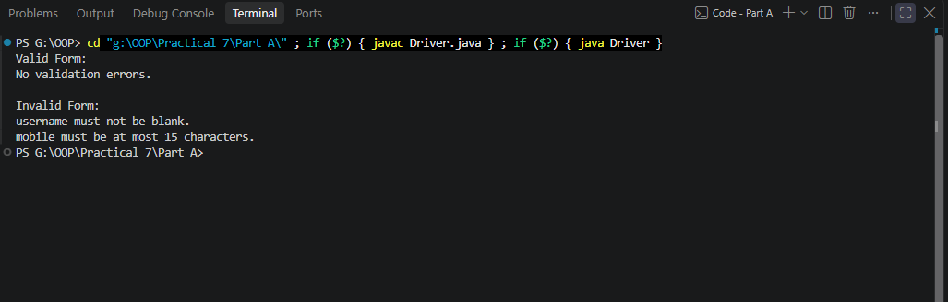

2. Mini test runner: define a @Run annotation and mark some no-arg methods of a class with it. Use reflection to find and invoke only the @Run methods and report how many ran — the idea behind how JUnit finds @Test methods.

Code:
Run.java
import java.lang.annotation.Retention;
import java.lang.annotation.RetentionPolicy;
import java.lang.annotation.Target;
import java.lang.annotation.ElementType;

@Retention(RetentionPolicy.RUNTIME)
@Target(ElementType.METHOD)
public @interface Run {
}

SampleTests.java
public class SampleTests {

@Run
public void testAddition() {
System.out.println("testAddition passed");
}

@Run
public void testSubtraction() {
System.out.println("testSubtraction passed");
}

public void helperMethod() {
System.out.println("This should NOT run.");
}

@Run
public void testMessage() {
System.out.println("testMessage passed");
}

public void normalMethod() {
System.out.println("This should NOT run.");
}
}

Driver.java
import java.lang.reflect.Method;

public class Driver1 {

public static void main(String[] args) {

SampleTests tests = new SampleTests();

int count = 0;

Method[] methods =
tests.getClass().getDeclaredMethods();

for (Method method : methods) {

if (method.isAnnotationPresent(Run.class)) {

try {
method.invoke(tests);
count++;
} catch (Exception e) {
System.out.println(
"Failed to run: " + method.getName()
);
}
}
}

System.out.println("\nTotal @Run methods executed: " + count);
}
}

Output:

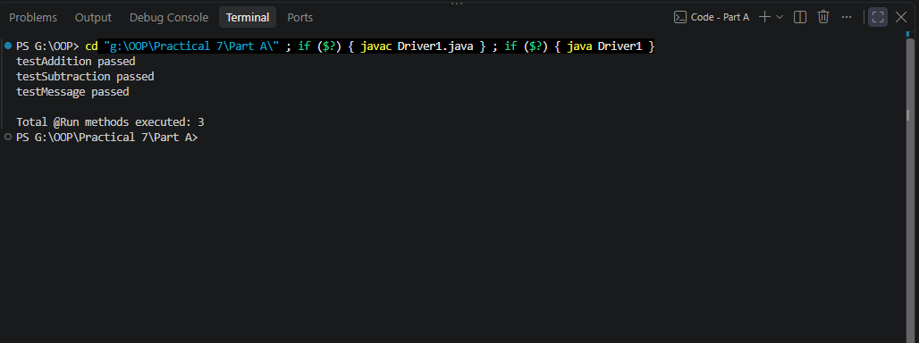

3. (For Advanced Learners – home) Define a @Column(name) annotation and, by reflection, populate an object’s fields from a header row and a data row by matching column names; decide how to handle a missing column.

Code:
Column.java
import java.lang.annotation.Retention;
import java.lang.annotation.RetentionPolicy;
import java.lang.annotation.Target;
import java.lang.annotation.ElementType;

@Retention(RetentionPolicy.RUNTIME)
@Target(ElementType.FIELD)
public @interface Column {

String name();
}

User.java
public class User {

@Column(name = "name")
private String name;

@Column(name = "id")
private String id;

@Column(name = "email")
private String email;

@Override
public String toString() {
return "User{name='" + name
+ "', id='" + id
+ "', email='" + email + "'}";
}
}

Mapper.java
import java.lang.reflect.Field;
import java.util.HashMap;
import java.util.Map;

public class Mapper {

public static <T> T populate(
Class<T> clazz,
String[] headers,
String[] data) throws Exception {

if (headers.length != data.length) {
throw new IllegalArgumentException(
"Header and data lengths do not match."
);
}

// Map column name -> value
Map<String, String> values = new HashMap<>();

for (int i = 0; i < headers.length; i++) {
values.put(headers[i], data[i]);
}

T object = clazz.getDeclaredConstructor().newInstance();

for (Field field : clazz.getDeclaredFields()) {

if (!field.isAnnotationPresent(Column.class)) {
continue;
}

Column column =
field.getAnnotation(Column.class);

String columnName = column.name();

if (!values.containsKey(columnName)) {
System.out.println(
"Warning: missing column '" + columnName + "'"
);
continue;
}

field.setAccessible(true);

String value = values.get(columnName);

field.set(object, value);
}

return object;
}
}

Driver.java
public class Driver2 {

public static void main(String[] args) throws Exception {

String[] headers = {
"name",
"id",
"email"
};

String[] data = {
"Riya",
"A07",
"riya@gmail.com"
};

User user =
Mapper.populate(
User.class,
headers,
data
);

System.out.println(user);
}
}

Output:
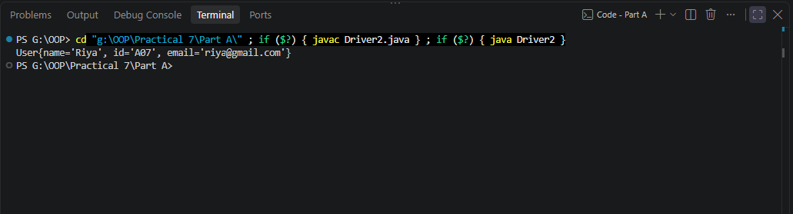

Key Questions / Analysis / Interpretation to be evaluated during/after Implementation

- What are the meta-annotations @Retention and @Target used for?

Ans.
@Retention and @Target are meta-annotations because they are used to define how other annotations behave.

@Retention
It specifies how long an annotation should be available.
Example:
@Retention(RetentionPolicy.RUNTIME)
This means the annotation is available at runtime, so reflection can read it.

@Target
It specifies where an annotation can be applied.
For example:
@Target(ElementType.FIELD)
means the annotation can only be used on fields:
@NotBlank
private String username;

- What is reflection, and what does getDeclaredFields() return?

Ans.

Reflection is a Java mechanism that allows a program to inspect and interact with classes, fields, methods, constructors, and annotations at runtime.
For example:
Class<?> clazz = object.getClass();
gets the runtime class of an object.
Then:
Field[] fields = clazz.getDeclaredFields();
returns an array containing the fields declared directly inside that class.
For example:
class SignupForm {

private String username;
private String email;
private String mobile;
}
Calling:
getDeclaredFields()
returns Field objects representing:
username
email
mobile
It includes fields regardless of their access modifier, such as private, public, or protected.

- How do annotations plus reflection let a framework validate any object?

Ans.
Annotations provide the rules, while reflection provides the mechanism to discover and apply those rules.
For example:
class SignupForm {

@NotBlank
@MaxLength(20)
private String username;

@NotBlank
private String email;
}
The framework doesn't need to write separate validation code specifically for SignupForm.

